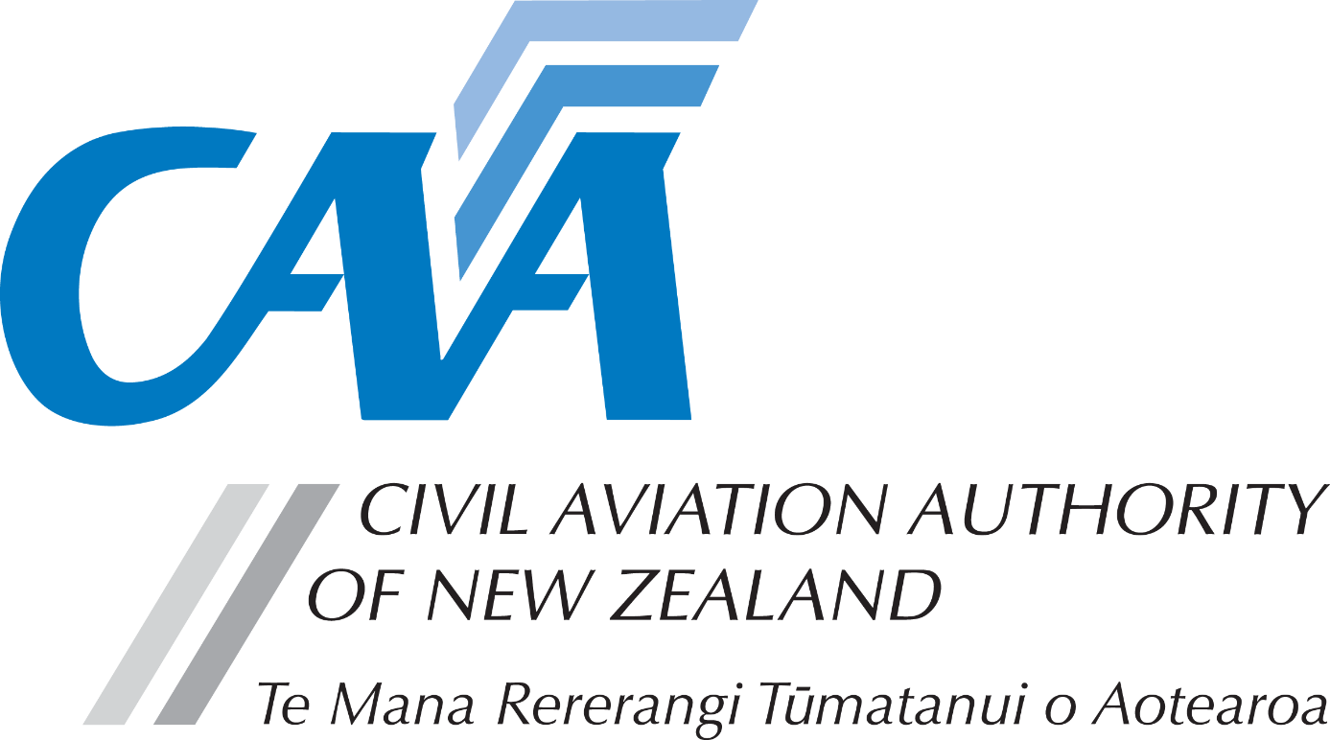
Aircraft Maintenance Engineer Licence and / or Category

Notes to applicants:
- A completed Fit and Proper Person Questionnaire, form CAA 24FPP or CAA 24FPPDEC, is required with this application. Refer to the 24FPP form for guidance on the appropriate form to be used.
- Personal details
CAA participant number (if known) |  |  |  |  |  |  | Date of birth (dd/mm/yy)
Title (Mr/Mrs/Ms/Miss) |  |  |  | Last name
Given name(s)
Country of birth |  |  |  |  |  | Nationality
Address for Service - Civil Aviation Act, s8, requires applicants to provide an address for service in New Zealand (i.e. a physical address) and to promptly notify the Director of any changes.
Phone |  |  |  | Mobile
Email
Postal Address (if different from Address for Service)
Phone |  |  |  | Mobile
Email
- Application requirements
- Requirements for AME licence issue are contained in Rule Part 66 and associated Part 66 Advisory Circulars (ACs)
- For details on licence issue requirements refer to AC 66-1 Subpart B Aircraft Maintenance Engineer Licence - page 16. Link to AC66-1.
- For further information, please refer the CAA website, www.aviation.govt.nz click on Licensing & Certification on the home page, then Maintenance engineer licensing.
- All applications must be accompanied by a suitable PTR detailing your experience as required by AC66-1
- Licence and/or category(s) applying for
Tick box to indicate licence and/or category required. | Initial AMEL Issue | ☐ | Aeroplane | ☐ | Rotorcraft | ☐
 | Powerplant | ☐ | Electrical | ☐ | Instrument | ☐
 | Radio | ☐ | LTA Aircraft | ☐

- Experience
Experience must be submitted in a suitable Practical Training Record (PTR) or similar document as required by AC66-1
1. Licence Issue
Demonstrate the required 3, 4 or 5 years maintenance experience, as required by Part 66, in a suitable PTR.
Additionally – for the Initial issue or your AME Licence include a CV type document that outlines your aviation maintenance career to date, or complete the Experience Overview section below.
2. Category Issue
Demonstrate 2 years experience relevant to the particular category sought in a suitable PTR.
3. Training Certificates
Include copies of relevant Training Certificates.

AC66-1 66.53(a)(4) - Practical experience and training (page 18)
“Practical experience for the issue of an AME Licence and Categories should be documented in a suitable Practical Training Record (PTR).
This should be set out or highlighted so the experience can be readily linked to the applicable licence and/or category that is being applied for.”
The format of any acceptable PTR should have the following features:
- provide an overview of experience /employment in the aviation industry, detailing relevant qualifications, training and courses
- list experience that must be detailed, accurate, comprehensive and verifiable
- list specific tasks completed, being countersigned by a supervising LAME
- provide details of the dates and the specific aircraft or components worked on.
As a guide, a typical PTR format is included in AC66-1 Appendix 4 and is electronically available on CAA web site under Maintenance engineer licensing – Practical experience.
Experience Overview (or CV supplied)
This is an overview only and still requires a detailed PTR to support your application.
It should be used to list any training, the types of aircraft, and levels and types of maintenance you have performed at the various companies or sections/ areas within a company you have been employed at.
Date
From | To | Employed at | Experience Overview (Concise accurate statements – print clearly)
From the experience outlined above, show the full time experience for licence and/or category sought.
 |  |  | Total Experience | Category | Experience (months)
Licence issue

- Fees and payment details
- The $299 licence fee includes one category. For each additional category, an additional $200 fee is required.
- Please pay online at https://sec.caa.govt.nz/onlinepayment and attach the receipt that will be emailed to you.
- For information relating to fees, refer to the Civil Aviation Charges Regulations.
Payment details
Licence fee (including 1 category) |  | $299
Additional categories requested | at $200 each
Total fees
Receipt number
- Declaration
The provision of false information or failure to disclose information relevant to the grant or holding of an aviation document constitutes an offence under Section 49 of the Civil Aviation Act 1990 and is subject, in the case of an individual, to imprisonment for a term not exceeding 12 months or to a fine not exceeding $10,000. | I declare that to the best of my knowledge and belief the statements made and the information supplied in this application and the attachments are complete and correct.  Consent to Disclosure & Collection  I authorise the collection by the Director of Civil Aviation or his delegate (hereinafter referred to as "the Director") from, and the disclosure to the Director by, any person, organisation or government department of any details of my knowledge & compliance with transport safety regulatory requirements.  I authorise the Director to use, and disclose, the information obtained about me for any purpose under the Civil Aviation Act 1990, or other such purpose permitted by law.
 | Applicant’s Signature |  | Date
- Applicant’s checklist
Please ensure all documents are enclosed.  Applications which are incomplete or lacking any required documents or PTR will be returned.  Please allow 10 working days, from date of receipt for processing your application. |  | Yes | N/A
 | - Payment receipt attached | ☐
 | - Copy of Training Certificates | ☐ | ☐
 | - Copy of Practical Training Record | ☐
 | - CV supplied, or Section 3 Experience Overview completed | ☐
 | - Fit and Proper Person Questionnaire completed – either 24FPP or 24FPPDEC | ☐ | ☐

Submit the completed application to either:
Email: lic.applications@caa.govt.nz
Post: Civil Aviation Authority, PO Box 3555, Wellington 6140, New Zealand

