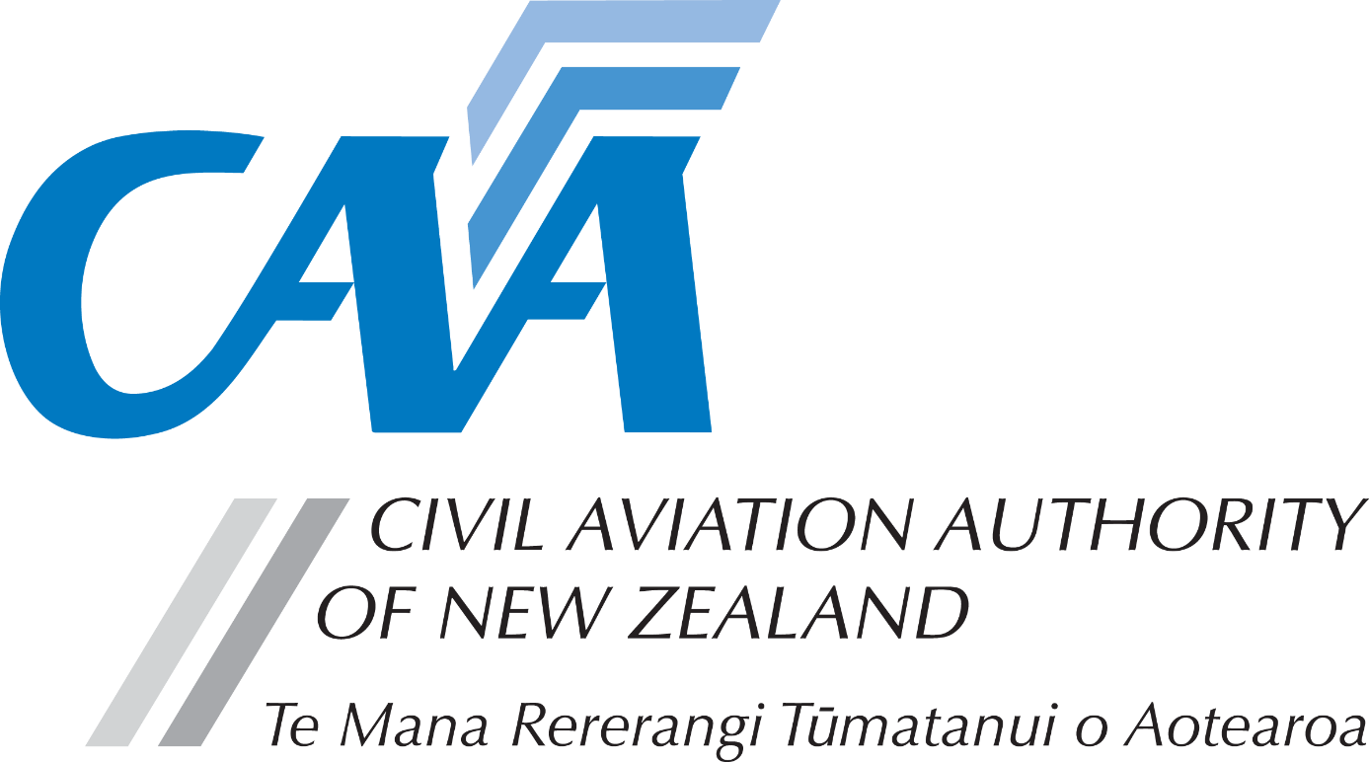
Application for Inspection Authorisation Certificate – Issue
Note for applicants: A completed Fit and Proper Person Questionnaire, form CAA 24FPP or CAA 24FPPDEC, is required with this application. Refer to the 24FPP form for guidance on the appropriate form to be used.

Personal details

CAA participant number |  |  |  |  |  | Date of birth
Name
Country of birth |  |  |  |  | Nationality
Address for service - Civil Aviation Act, s8, requires applicants to provide an address for service in New Zealand (i.e. a physical address) and to promptly notify the Director of any changes.
Phone |  |  | Email
Postal address (if different from address for service)
Phone |  |  | Email

Application details

Application for:
Certificate Issue | ☐ | Avionics | ☐ |  | Mechanical |  | ☐
I agree to my name being published and/or listed in electronic media as being the holder of an Inspection Authority. |  |  |  | Yes ☐ |  | No ☐
Note: separate application required on Form 24066-11 for Inspection Authorisation course

Fees & payment details
- Please pay online at https://sec.caa.govt.nz/onlinepayment and attach the receipt that will be emailed to you.
- Unless the full fees are paid and receipt is attached, applications will not be processed.
- For information relating to fees, refer to the Civil Aviation Charges Regulations.
Payment details
Total fees
Receipt number

Declaration

The provision of false information or failure to disclose information relevant to the grant or holding of an aviation document constitutes an offence under Section 49 of the Civil Aviation Act 1990 and is subject, in the case of an individual, to imprisonment for a term not exceeding 12 months or to a fine not exceeding $10,000. | I declare that to the best of my knowledge and belief the statements made and the information supplied in this application and the attachments are complete and correct.  Consent to disclosure & collection  I authorise the collection by the Director of Civil Aviation or his delegate (hereinafter referred to as "the Director") from, and the disclosure to the Director by, any person, organisation or government department of any details of my knowledge & compliance with transport safety regulatory requirements.  I authorise the Director to use, and disclose, the information obtained about me for any purpose under the Civil Aviation Act 1990, or other such purpose permitted by law.  I hereby certify that I have met the eligibility requirements for the issue of an Inspection Authorisation Certificate in Rule 66.203 and the recent experience requirements for AMEL in Rule 66.57.
 | Applicant’s signature |  | Date

Applicant’s checklist
Please ensure all documents are enclosed. Applications which are incomplete or lacking any required documents will be returned. | - Proof of payment – for fee(s) ☐  - 24FPP or 24FPPDEC ☐

Submit the completed application and supporting documents to either:

Email: lic.applications@caa.govt.nz

Post: Civil Aviation Authority, PO Box 3555, Wellington 6140, New Zealand

