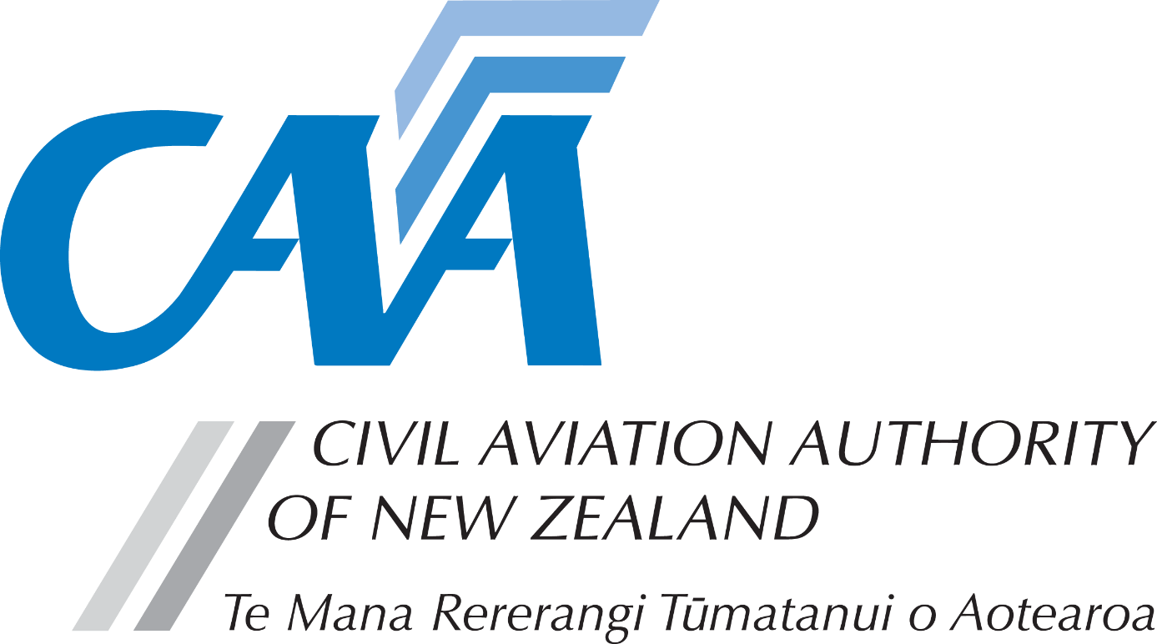
Trans-Tasman Mutual Recognition Act – Licence Registration – AME
1. Personal details
CAA participant number (if known) |  |  |  |  |  |  |  |  |  | Date of birth (dd/mm/yy)
Title (Mr/Mrs/Ms/Miss) |  |  |  |  | Last name
Given name(s)
Country of birth |  |  |  |  |  |  |  | Nationality
New Zealand address for service - Civil Aviation Act, s8, requires applicants to provide an address for service in New Zealand (i.e. a physical address) and to promptly notify the Director of any changes.
Phone |  |  |  |  | Mobile
Email
Australian Residential Address
Phone |  |  |  |  | Mobile
Email
Address to which letter of registration should be sent |  |  | Residential Address |  |  | ☐ |  |  | NZ address for service |  |  | ☐
2. Application requirements
- You must have an “address for service” in New Zealand.
- You must enclose a certified copy of your Australian AME Licence with this registration form.
- For further information, please refer the CAA website, https://www.aviation.govt.nz > Licensing & Certification > Maintenance engineer licensing.
3. Fees & payment details
- Please pay online at https://sec.caa.govt.nz/onlinepayment and attach the receipt that will be emailed to you.
- Unless the full fees are paid and receipt is attached, applications will not be processed.
- For information relating to fees, refer to the Civil Aviation Charges Regulations.
Payment details
Total fees
Receipt number

4. Declaration
The provision of false information or failure to disclose information relevant to the grant or holding of an aviation document constitutes an offence under Section 49 of the Civil Aviation Act 1990 and is subject, in the case of an individual, to imprisonment for a term not exceeding 12 months or to a fine not exceeding $10,000. | I declare that to the best of my knowledge and belief the statements made and the information supplied in this application and the attachments are complete and correct.  Consent to disclosure & collection  I authorise the collection by the Director of Civil Aviation or his delegate (hereinafter referred to as "the Director") from, and the disclosure to the Director by, any person, organisation or government department of any details of my knowledge & compliance with transport safety regulatory requirements.  I authorise the Director to use, and disclose, the information obtained about me for any purpose under the Civil Aviation Act 1990, or other such purpose permitted by law.
 | Applicant’s signature |  | Date
5. Applicant’s checklist
Please ensure all documents are enclosed. Applications which are incomplete or lacking any required documents will be returned. | - Certified copy of Australian AME Licence | ☐
 | - Payment receipt | ☐

Submit the completed application to either:
Email: lic.applications@caa.govt.nz
Post: Licensing and Standards, Civil Aviation Authority, PO Box 3555, Wellington 6140, New Zealand

