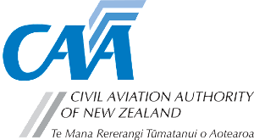
Agreement to supply manufacturer’s data

Tick appropriate box : Aircraft  Engine  Propeller  Other 
Make: |  |  | Model:
I hereby undertake to supply to the Director of Civil Aviation, at no charge and as soon as practicable after issue, one copy of all amendments and re-issues to the following manufacturer’s manuals necessary for the maintenance and safe operation of the above model, including service letters and bulletins and the aircraft flight manual, if applicable:
Flight manual data is to be sent to:  Flight Manual Coordinator Airworthiness  Civil Aviation Authority of New Zealand PO Box 3555  Wellington 6140 New Zealand |  |  | All other data is to be sent to:  The Certification Unit  Civil Aviation Authority of New Zealand PO Box 3555  Wellington 6140 New Zealand
In addition, I hereby agree to supply at no charge copies of any design or certification reports as may be requested by the Director of Civil Aviation, in support of certification or continuing airworthiness of this model, as listed in the following document:
Note: Such propriety data is held on a confidential basis and not supplied to any other party without the written permission of the owner of the data.
Signed: |  |  | Signature:
On behalf of:
Position: |  |  |  |  |  | Date:

CAA 2171
Page 1 of 1 Rev 5 : April 2025

