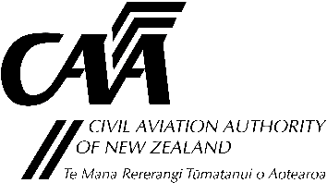
Part 115 application for removal of parachute, hang glider, or paraglider
Note: This form is to be attached to an application for issue or renewal of an adventure aviation operator certificate.
Use this form to remove aircraft that have been withdrawn, destroyed, or transferred to private ownership. If a change of possession is required, use the appropriate Part 115 change of possession application form.
Section A: Client Details
Registered Owner
Company name / Surname Forename(s) Client ID No. (if known)
Contact person |  | Mobile No. |  | Tel No.
Section B: Aircraft Description and Reason for Removal
Aircraft
Manufacturer
Model Designation: |  | Serial No:
Reason for Removal: |  | CAA ID No:  CAA to complete only
Aircraft
Manufacturer
Model Designation: |  | Serial No:
Reason for Removal: |  | CAA ID No:  CAA to complete only
Aircraft
Manufacturer
Model Designation: |  | Serial No:
Reason for Removal: |  | CAA ID No:  CAA to complete only
Aircraft
Manufacturer
Model Designation: |  | Serial No:
Reason for Removal: |  | CAA ID No:  CAA to complete only
NOTE: If you have more aircraft, use additional sheets and complete Section B.
Submit the completed application and supporting documentation to either:
Email: certification@caa.govt.nz
Post: Certification Unit, Civil Aviation Authority, PO Box 3555, Wellington 6140

