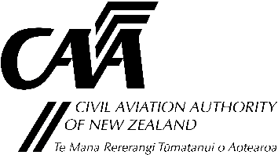
Part 19, Subpart F supply organisation exposition – amendment notification

Use this form to:
- Identify changes made to your exposition; and
- Assess whether any of these changes require prior acceptance by CAA.
If that is the case you will need to make a formal application by submitting the appropriate form (CAA 24019-01).
This form is used by CAA to determine how to deal with your exposition amendment.
Use it as a checklist to avoid the inconvenience of having CAA return to you any exposition amendment that is incorrect or incomplete.
- Organisation Details
Participant no. |  | Name of organisation
- Changes to Exposition
Manual name |  | Amendment no.  and date
Summary of changes
- Self-assessment
- Do the changes to the exposition relate to any of the requirements of rule 19.329(d), which requires prior acceptance by the Director? - as listed below |  | Yes | No
 | the Chief Executive:
 | the listed senior persons:
 | the locations at which work is carried out.
- Do any of the changes affect the organisation’s Exposition Acceptance document?
If you have answered ‘YES’ to any of these questions, make an application for amendment to your certificate of approval for supply.
Submit the appropriate application form (CAA 24019-01). Include the amended draft exposition and this form.
If you have answered ‘NO’ to all of these questions, send in your exposition amendment with this form.
No application is required.

- Previous Application
Are the changes made in response to an earlier application or submission that is currently being assessed by the CAA? |  |  |  |  | Yes | No
If Yes |  | Change to your organisation under rule 19.329(d) or other information on the Exposition Acceptance |  | Work request/case no.
If Yes |  | Response to an audit finding |  | Work request/case or finding no.
Who within CAA is processing this change?
(if known)
- Changes Submitted by
Submitted by |  | Position |  | Date
Email

Submit the completed form and supporting documents to either:
Email: certification@caa.govt.nz
Post: Certification Unit, Civil Aviation Authority, PO Box 3555, Wellington 6140

