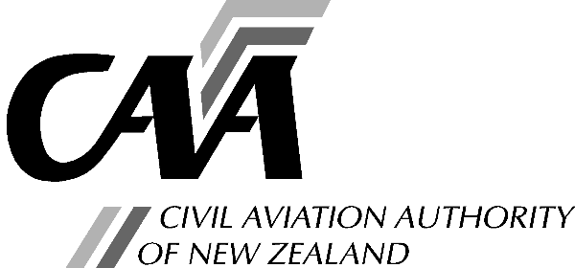***Part 21 application for change to a type certificate***

Note: The CAA Standard Rate hourly charge applies.

Instructions and advice for completing this Application Form

1.

2.

3.

Refer to CAR Part 21B or 21D before completing this application.

Entries should be typed or printed in block letters.

Forward completed application to:

**Manager Aircraft Certification Civil Aviation Authority**

**PO Box 3555**

**Wellington 6140**

Section A: Applicant

|  |  |  |  |  |  |  |  |  |  |  |  |  |
| --- | --- | --- | --- | --- | --- | --- | --- | --- | --- | --- | --- | --- |
| a. Legal Name of Applicant: | | | | | |  | | | | | | |
| b. Design Organisation Certificate No: | | | | | |  | | | |  | | |
| *Note: Under CAR Part 21.15 only the holder of an applicable Design Organisation Certificate may apply for the grant of a Type Certificate. Under 21.99 only the holder of a Type Certificate may apply for a change to a Type Certificate.* | | | | | | | | | | | | |
| c. Address for Service: *Civil Aviation Act, s73, requires applicants to provide an address for service (ie, a physical address) and to promptly notify the Director of any changes.* | | | |  | | | | | | | | |
|  | | | | | | | | |
|  | | | | | | | | |
|  | | | | | | | | |
| Tel: |  | | Fax: | |  | | Email: |  | | | | |
| Postal Address: (If different from Address for Service.) | |  | | | | | | | | | | |
|  | | | | | | | | | | |
|  | | | | | | | | | | |
|  | | | | | | | | | | |
| Tel: |  | | Fax: | |  | | Email: |  | | | | |
| d. Person who can be contacted for further information concerning this application: | | | | | | | | | | | | |
| Name: | | | | |  | | | | | | | |
| Position: | | | | |  | | | | | | | |
| Postal Address: | | | | |  | | | | | | | |
|  | | | | |  | | | | | | | |
|  | | | | |  | | | | | | | |
| Telephone: | | | | |  | | | | Fax: | |  | |
| 1. Has the organisation been convicted of any transport safety offence in the last five years or is the organisation presently facing charges for a transport safety offence? 2. Has the organisation previously had an application for an aviation document rejected or has an aviation document held by the organisation been suspended or revoked? | | | | | | | | | | | *Yes | No |
| ***\* If answering “Yes” to either e. or f. please provide details on separate sheets.*** | | | | | | | | | | | | |

Section B: Reason for Application

|  |  |
| --- | --- |
| Initial issue Change | |
| If a change, give brief details of change to Certificate: |  |
|  | |
|  | |
|  | |
|  | |
|  | |
|  | |

Section C: Product Type Details

|  |  |
| --- | --- |
| a. Product Type  Aircraft  Engine  Propeller | |
| b. Product Model Designation(s): |  |
|  | |
|  | |
|  | |
|  | |
| c. If an Aircraft, category of Type Certificate applied for:  Standard Restricted If Restricted, give details of the operational purposes for the aircraft | |
|  | |
|  | |
|  | |
|  | |

Section D: Supply of Data

|  |
| --- |
| The following listed data is enclosed to satisfy the requirements of CAR Part 21.17(a) or 21.101(2) to (4):  *Notes: 1. For an aircraft, a three view drawing and available preliminary basic data.*   1. *For an engine or propeller, a description of the design features, operating characteristics and proposed operating limitations.* 2. *For a change to a type certificate, technical data to define the change, identification and documentation of any investigations and/or tests necessary to show compliance with the applicable design requirements, and a statement of conformity.* |
|  |
|  |
|  |
|  |

Section E: Application

I hereby apply for the change to a Type Certificate covering the product type stated above in Section C. I understand and am able to undertake the responsibilities of a type certificate holder as specified in 21.51 to 21.57.

I declare that to the best of my knowledge and belief the statements made and the information supplied in this application and the attachments are complete and correct.

Full Name:

Signature:

Date:

*Note: The provision of false information or failure to disclose information relevant to the grant or holding of an aviation document constitutes an offence under sections 107 and 362, respectively, of the Civil Aviation Act 2023 and is subject, in the case of a person other than an individual, to a maximum fine of $100,000.*