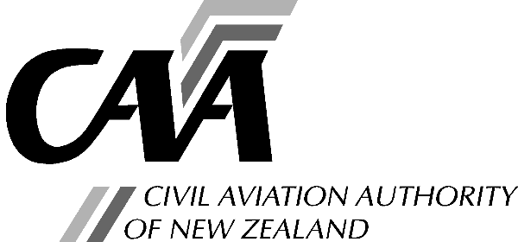***Part 21 application for issue or amendment of a supplemental type certificate***

Note: The CAA Standard Rate hourly charge applies.

Instructions and advice for completing this Application Form

|  |
| --- |
| 1. Entries should be typed or printed in block letters. |
| 2. Scan this form and email to [certification@caa.govt.nz,](mailto:certification@caa.govt.nz) or post to Certification Manager Aircraft and Product, Civil Aviation Authority, PO Box 3555, Wellington 6140. |

Section A: Applicant Details

|  |  |  |  |  |  |  |  |  |  |  |  |  |  |  |
| --- | --- | --- | --- | --- | --- | --- | --- | --- | --- | --- | --- | --- | --- | --- |
| a. Applicant: | | |  | | | | | | |  |  |  |  |  |
|  | | |  | Organisation name (or individual name if applicable) | | | |  |  | Client No. (if known) | | | |  |
| b. *Address for Service: Civil Aviation Act, s73, requires applicants to provide an address for service in New Zealand (ie, a physical address) and to promptly notify the Director of any changes.* | | | | |  | | | | | | | | | |
|  | | | | | | | | | |
|  | | | | | | | | | |
|  | | | | | | | | | |
| Tel: |  | | | | | | Email: |  | | | | | | |
| Postal Address: *(If different from Address for Service.)* | | |  | | | | | | | | | | | |
|  | | | | | | | | | | | |
|  | | | | | | | | | | | |
|  | | | | | | | | | | | |
| Tel: | |  | | | | | Email: |  | | | | | | |
| c. Person who can be contacted for further information concerning this application: | | | | | | | | | | | | | | |
| Name: | | |  | | | | | | | | | | | |
| Position: | | |  | | | | | | | | | | | |
| d. Has the organisation been convicted of any transport safety offence in | | | | | | | | | **Yes\*** | |  | **No** |  | |
| the last five years or is the organisation presently facing charges for a | | | | | | | | | | | | | | |
| transport safety offence? | | | | | | | | | | | | | | |
| e. Has the organisation previously had an application for an aviation document | | | | | | | | | | | | | | |
| rejected or has an aviation document held by the organisation been suspended | | | | | | | | | | | | | | |
|  |  | or revoked? |  |  |  |  |  |  |  |  |  |  |  |  |
| ***\*(if answering yes, to either d or e, please give details on separate sheets).*** | | | | | | | | | | | | | | |

Section B – Details for Invoice

|  |
| --- |
| Please provide the name of the organisation or individual, and address for the invoice to be sent. |
|  |
|  |

Section C: Application Type

|  |  |  |
| --- | --- | --- |
| New Issue | Amendment |  |

Section D: Product and Type Certificate Change

|  |  |
| --- | --- |
| a. Make and model of product to be |  |
| modified. (Including serial number |  |
| range if appropriate.) |  |
| b. Applicable Type Certificate |  |
| c. Description of change to Type |  |
| Certificate. |  |

Section E: Information Supplied

|  |  |  |
| --- | --- | --- |
| The information listed below is supplied as required by rule 21.117(2) in support of this application: | | |
| Documentation necessary to define the data or describe the design change: | |  |
|  | | |
|  | | |
|  | | |
|  | | |
|  | | |
|  | | |
|  | | |
| Identification and documentation of any investigations and/or tests necessary to show compliance with the applicable design requirements: | | |
|  | | |
|  | | |
|  | | |
|  | | |
|  | | |
|  | | |
| Maintenance and Operating data: |  | |
|  | | |
|  | | |
|  | | |
|  | | |
|  | | |
| A statement of compliance from a certificated design organisation, or a foreign equivalent, or a written request that a statement of compliance be provided during the technical data approval process: | | |
|  | | |
|  | | |
|  | | |

Section F: Declaration

This application is made for and on behalf of the applicant identified above. I understand and am able to undertake the responsibilities of a supplemental type certificate holder as detailed in rule 21.123.

I declare that to the best of my knowledge and belief the statements made and the information supplied in this application and the attachments are complete and correct.

Signature:

Date:

*Note: The provision of false information or failure to disclose information relevant to the grant or holding of an aviation document constitutes an offence under sections 107 and 362, respectively, of the Civil Aviation Act 2023 and is subject, in the case of a person other than an individual, to a maximum fine of $100,000.*